Learn

Because the data came from a crowdsourced community site, it could contain errors. If you plot a histogram of the values in the Year column, which describes the year Marvel introduced each Avenger, you'll immediately notice some oddities. For example, there are quite a few Avengers who look like they were introduced in 1900, which we know is a little fishy -- the Avengers weren't introduced in the comic series until the 1960's!

This is obviously a mistake in the data. As a result, you should remove all of the Avengers introduced before 1960 from the dataframe.

Instructions

* We only want to keep the Avengers who were introduced after 1960.
  + Store only the rows describing Avengers added in 1960 or later in true_avengers.

import matplotlib.pyplot as plt

true_avengers = pd.DataFrame()

# all years with errors

avengers['Year'].hist()

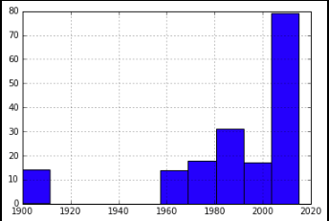

true_avengers = avengers[avengers['Year'] > 1959]

true_avengers['Year'].hist()

